Model Training and Testing Report

By Group 25

# SUMMARY

Here is a summary of the CNN used for training: 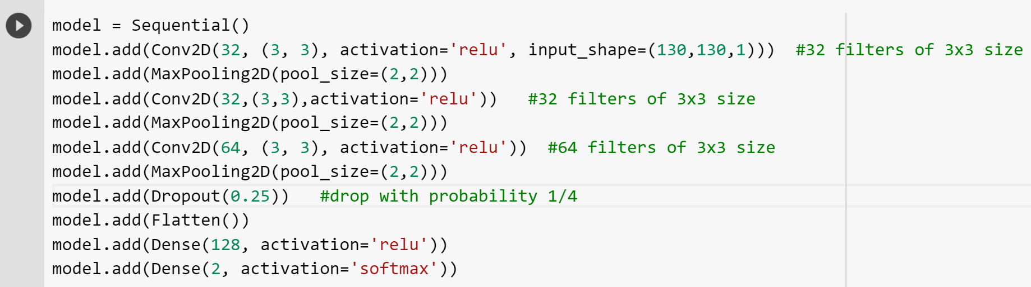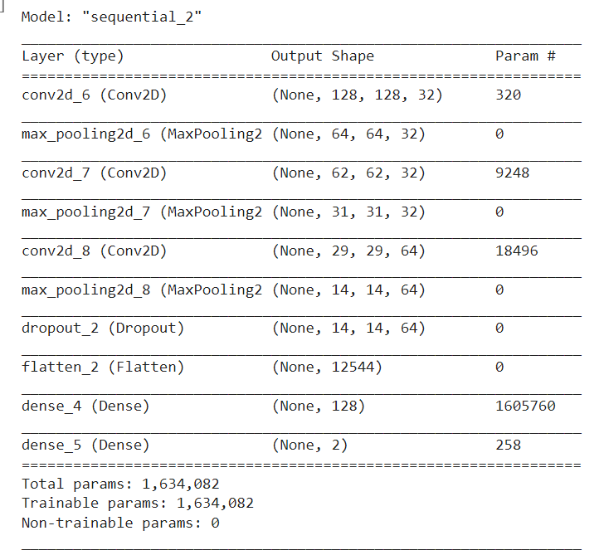

# TRAINING

The following parameters were used in compiling the model:

1. optimizer='adam' - adaptive momentum optimizer
2. loss='sparse_categorical_crossentropy' - difference between PMFs
3. metrics=['accuracy'] - accuracy = (TP+TN)/(TP+FP+TN+FN), this is a good measure since the train dataset has equal representation of both classes.
4. # train data points = 987, # validation data points = 247

Progress over 10 epochs:

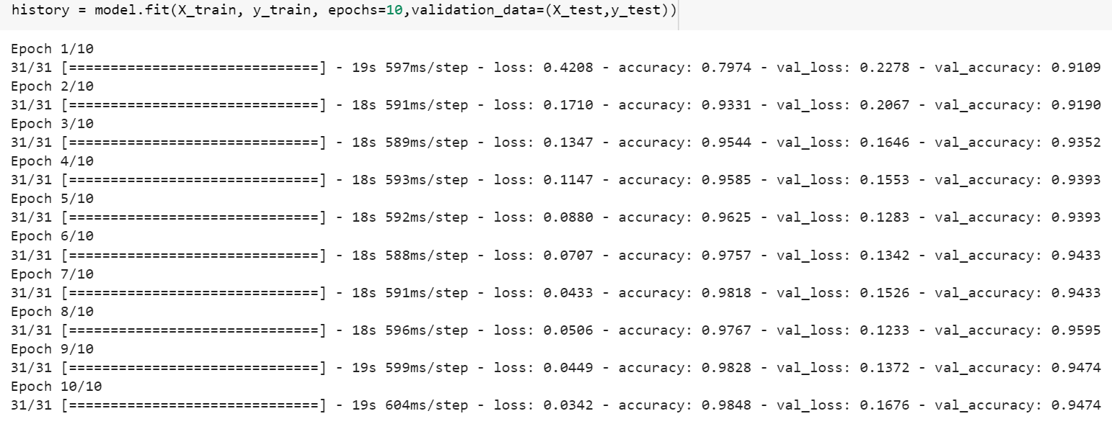

# 

# 

# 

# VERIFICATION

The test dataset had 218 images, with equal samples from both classes. The loss and accuracy obtained are:

7/7 [==============================] - 0s 13ms/step - loss: 0.1337 - accuracy: 0.9633

[0.13366732001304626, 0.963302731513977]

The confusion matrix is plotted below:

[[108 1]

[ 7 102]]

